Gastrin short notes
- No specific information about the transport of progastrin to the ER by SRP was found. We assumed that this was a general pathway for many secretory proteins, which is the case for gastrin, and therefore included it.
- For the GPR rules of the SRP enzyme it is unclear whether SRP68 and SRP72 have to be both present in order for it to work as the image suggests either of them can be present. This is also observed in SRP9 and SRP14. 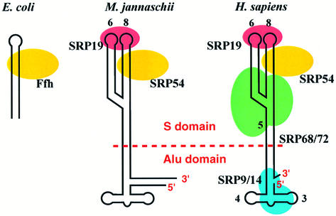
From: NEW EMBO MEMBER’S REVIEW: Structure, function and evolution of the signal recognition particle - PMC

- Unlike most peptide hormones, gastrin synthesis does not include disulfide bond formation, as progastrin does not have cysteine residues in its amino acid sequence.
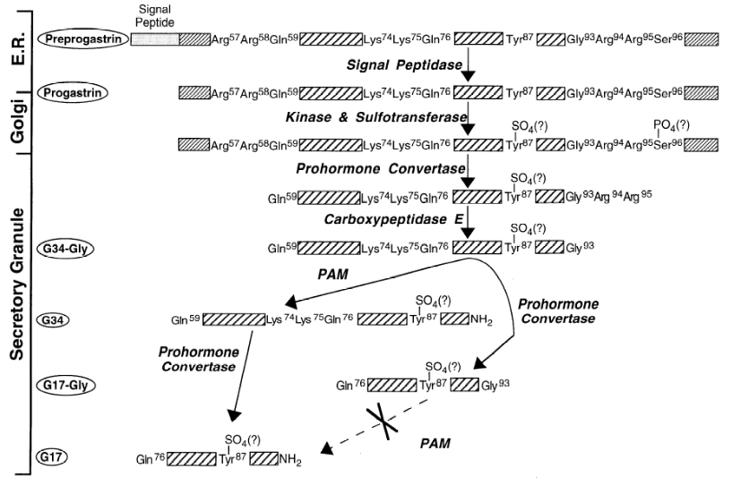
From: Gastrin Processing: From Biochemical Obscurity to Unique Physiological Actions
- Literature suggests that progastrin does not require folding in order to be transported from the ER to the golgi and it enters the Golgi apparatus as a dodecapeptide sequence that later undergoes post translational modifications. We assumed there was no folding, only processing by post-translational modifications.
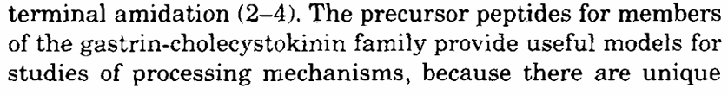
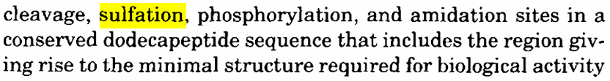
From: https://www.jbc.org/article/S0021-9258(17)32058-6/pdf

- Ca2+ seems to be involved in progastrin stability
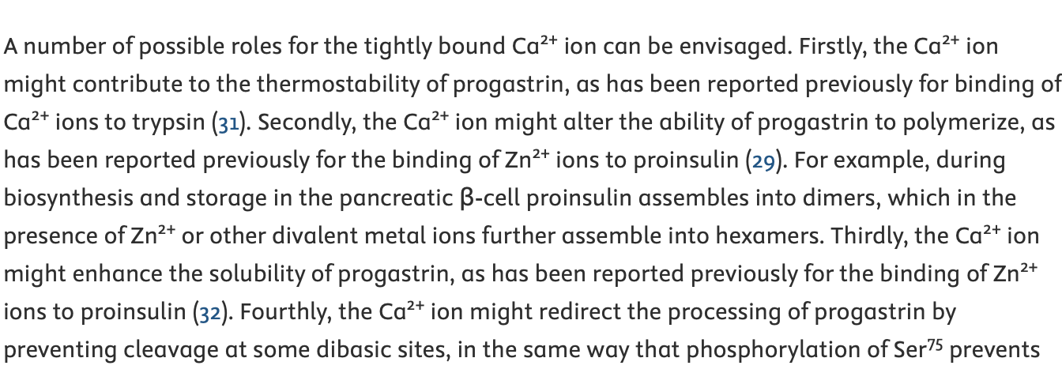
From: https://www.jbc.org/article/S0021-9258(19)32117-9/fulltext
- No specific information on how gastrin goes from the ER to the Golgi apparatus. However, since this process seems to be common for most prohormones, we included it (COPII coated vesicles).
- Unclear information about the order in which the post-translational modifications happened in the Golgi. We assumed sulfation occurs first and then phosphorylation.

